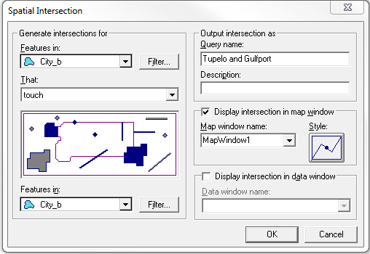

Making Spatial Intersection for the isolation of cities: Tupelo and Gulfport, based on MS.mdb provided by CAIT

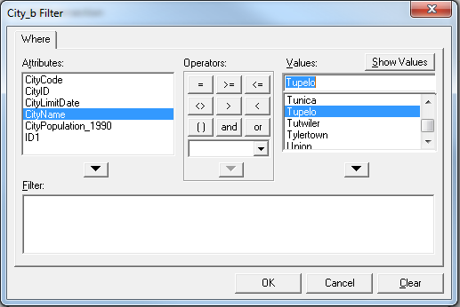

Filtering by CityName attribute during creation of Spatial Intersection

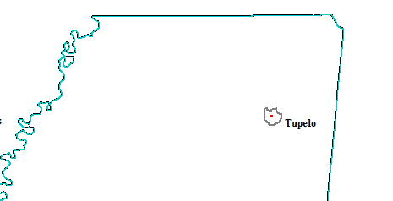

Isolated Tupelo Feature

NOTE: Features reflect the CAIT Specifications with the addition of City Border as defined by William Rossell.

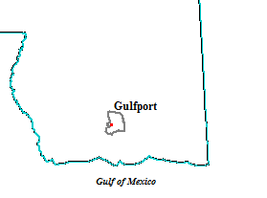

Isolated Gulfport Feature

NOTE: Features reflect the CAIT Specifications with the addition of City Border as defined by William Rossell.

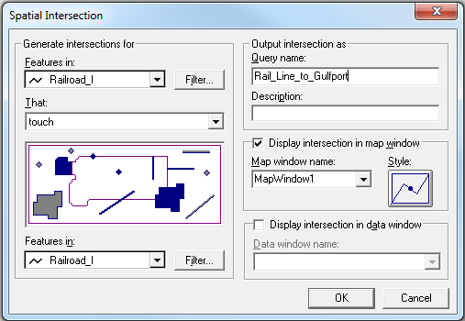

Making Spatial Intersection for the isolation of railways between the cities: Tupelo and Gulfport, based on MS.mdb provided by CAIT

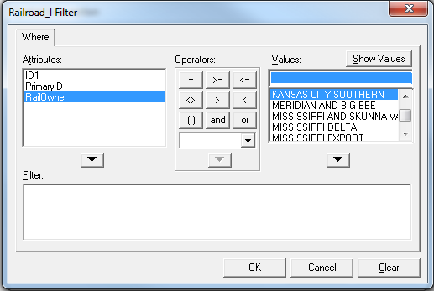

Filtering by RailOwner attribute during creation of Spatial Intersection

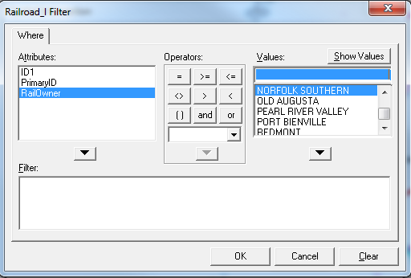

Filtering by RailOwner attribute during creation of Spatial Intersection

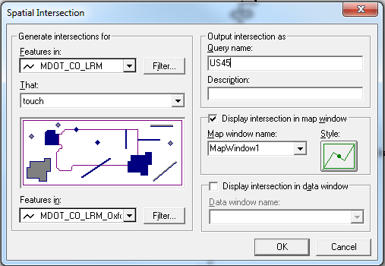

Making Spatial Intersection for the isolation of US45 between the cities: Tupelo and Gulfport, based on MS.mdb provided by CAIT

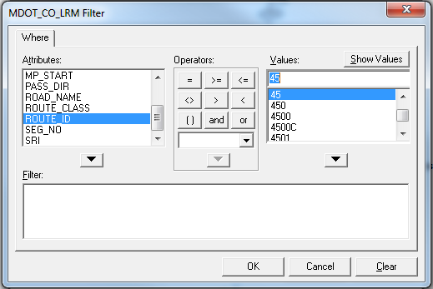

Filtering by ROUTE_ID attribute during creation of Spatial Intersection

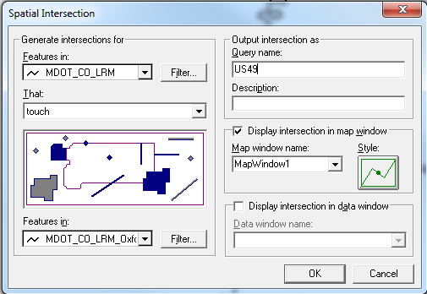

Making Spatial Intersection for the isolation of US49 between the cities: Tupelo and Gulfport, based on MS.mdb provided by CAIT

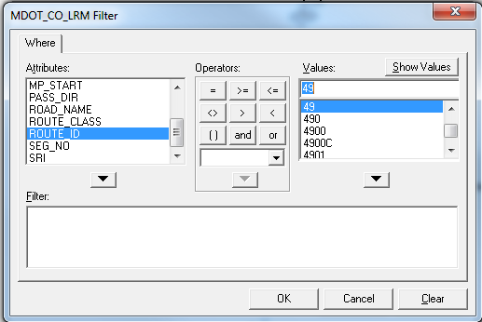

Filtering by ROUTE_ID attribute during creation of Spatial Intersection

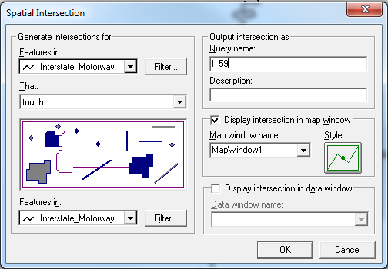

Making Spatial Intersection for the isolation of I-59 between the cities: Tupelo and Gulfport, based on MS.mdb provided by CAIT

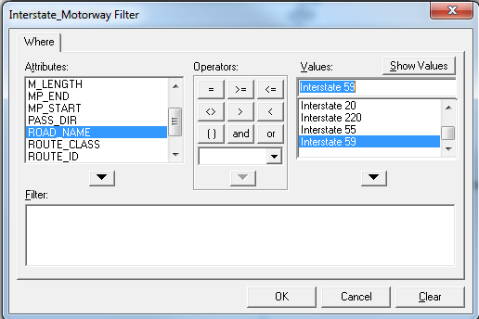

Filtering by ROAD_NAME attribute during creation of Spatial Intersection

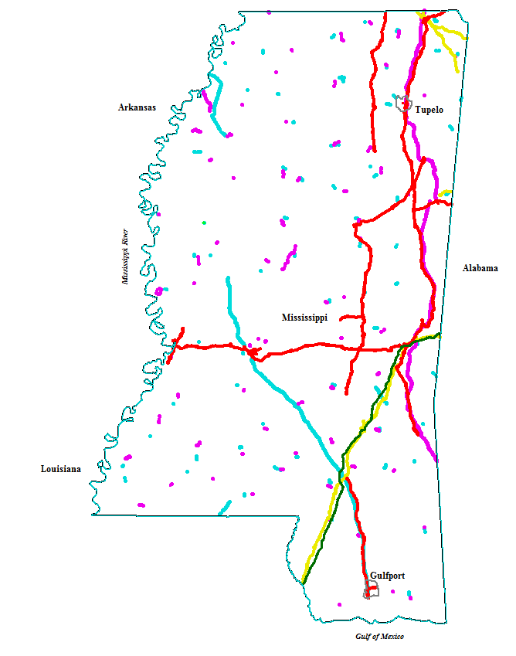 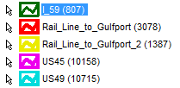

Geoworkspace after creation of initial Spatial Intersections.

NOTE: Features do not yet reflect CAIT Specifications

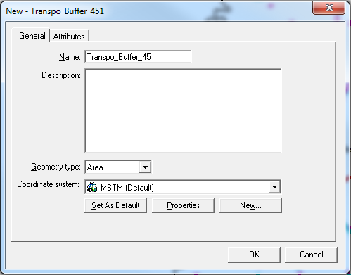

Creating a new feature class for buffering roadways

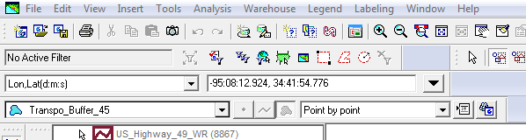

Creating a buffer to isolate US45

>>Insert>>Feature>>Point by Point

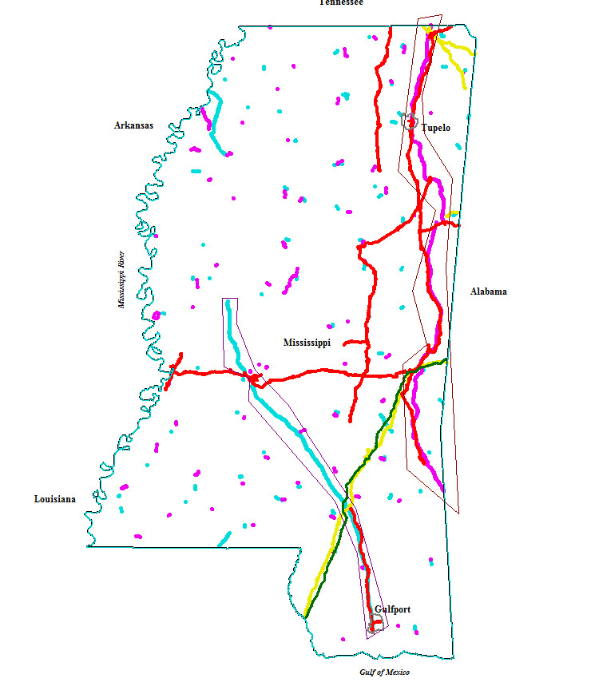

Buffering Roadways US45 and US49

NOTE: Features do not yet reflect CAIT Specifications

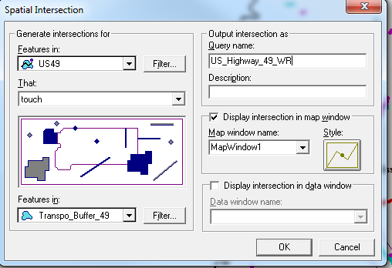

Using Spatial Intersection to isolate direct roadways from excess features presented in the GeoWorkspace

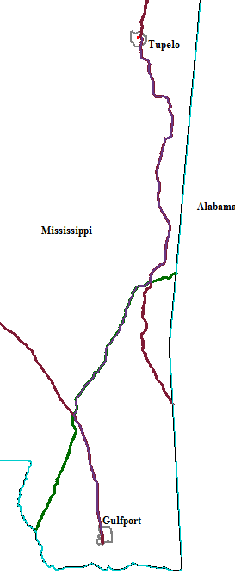

Creating Planimetric Overlay of Roadways to Measure Trip Distance from Tupelo to Gulfport

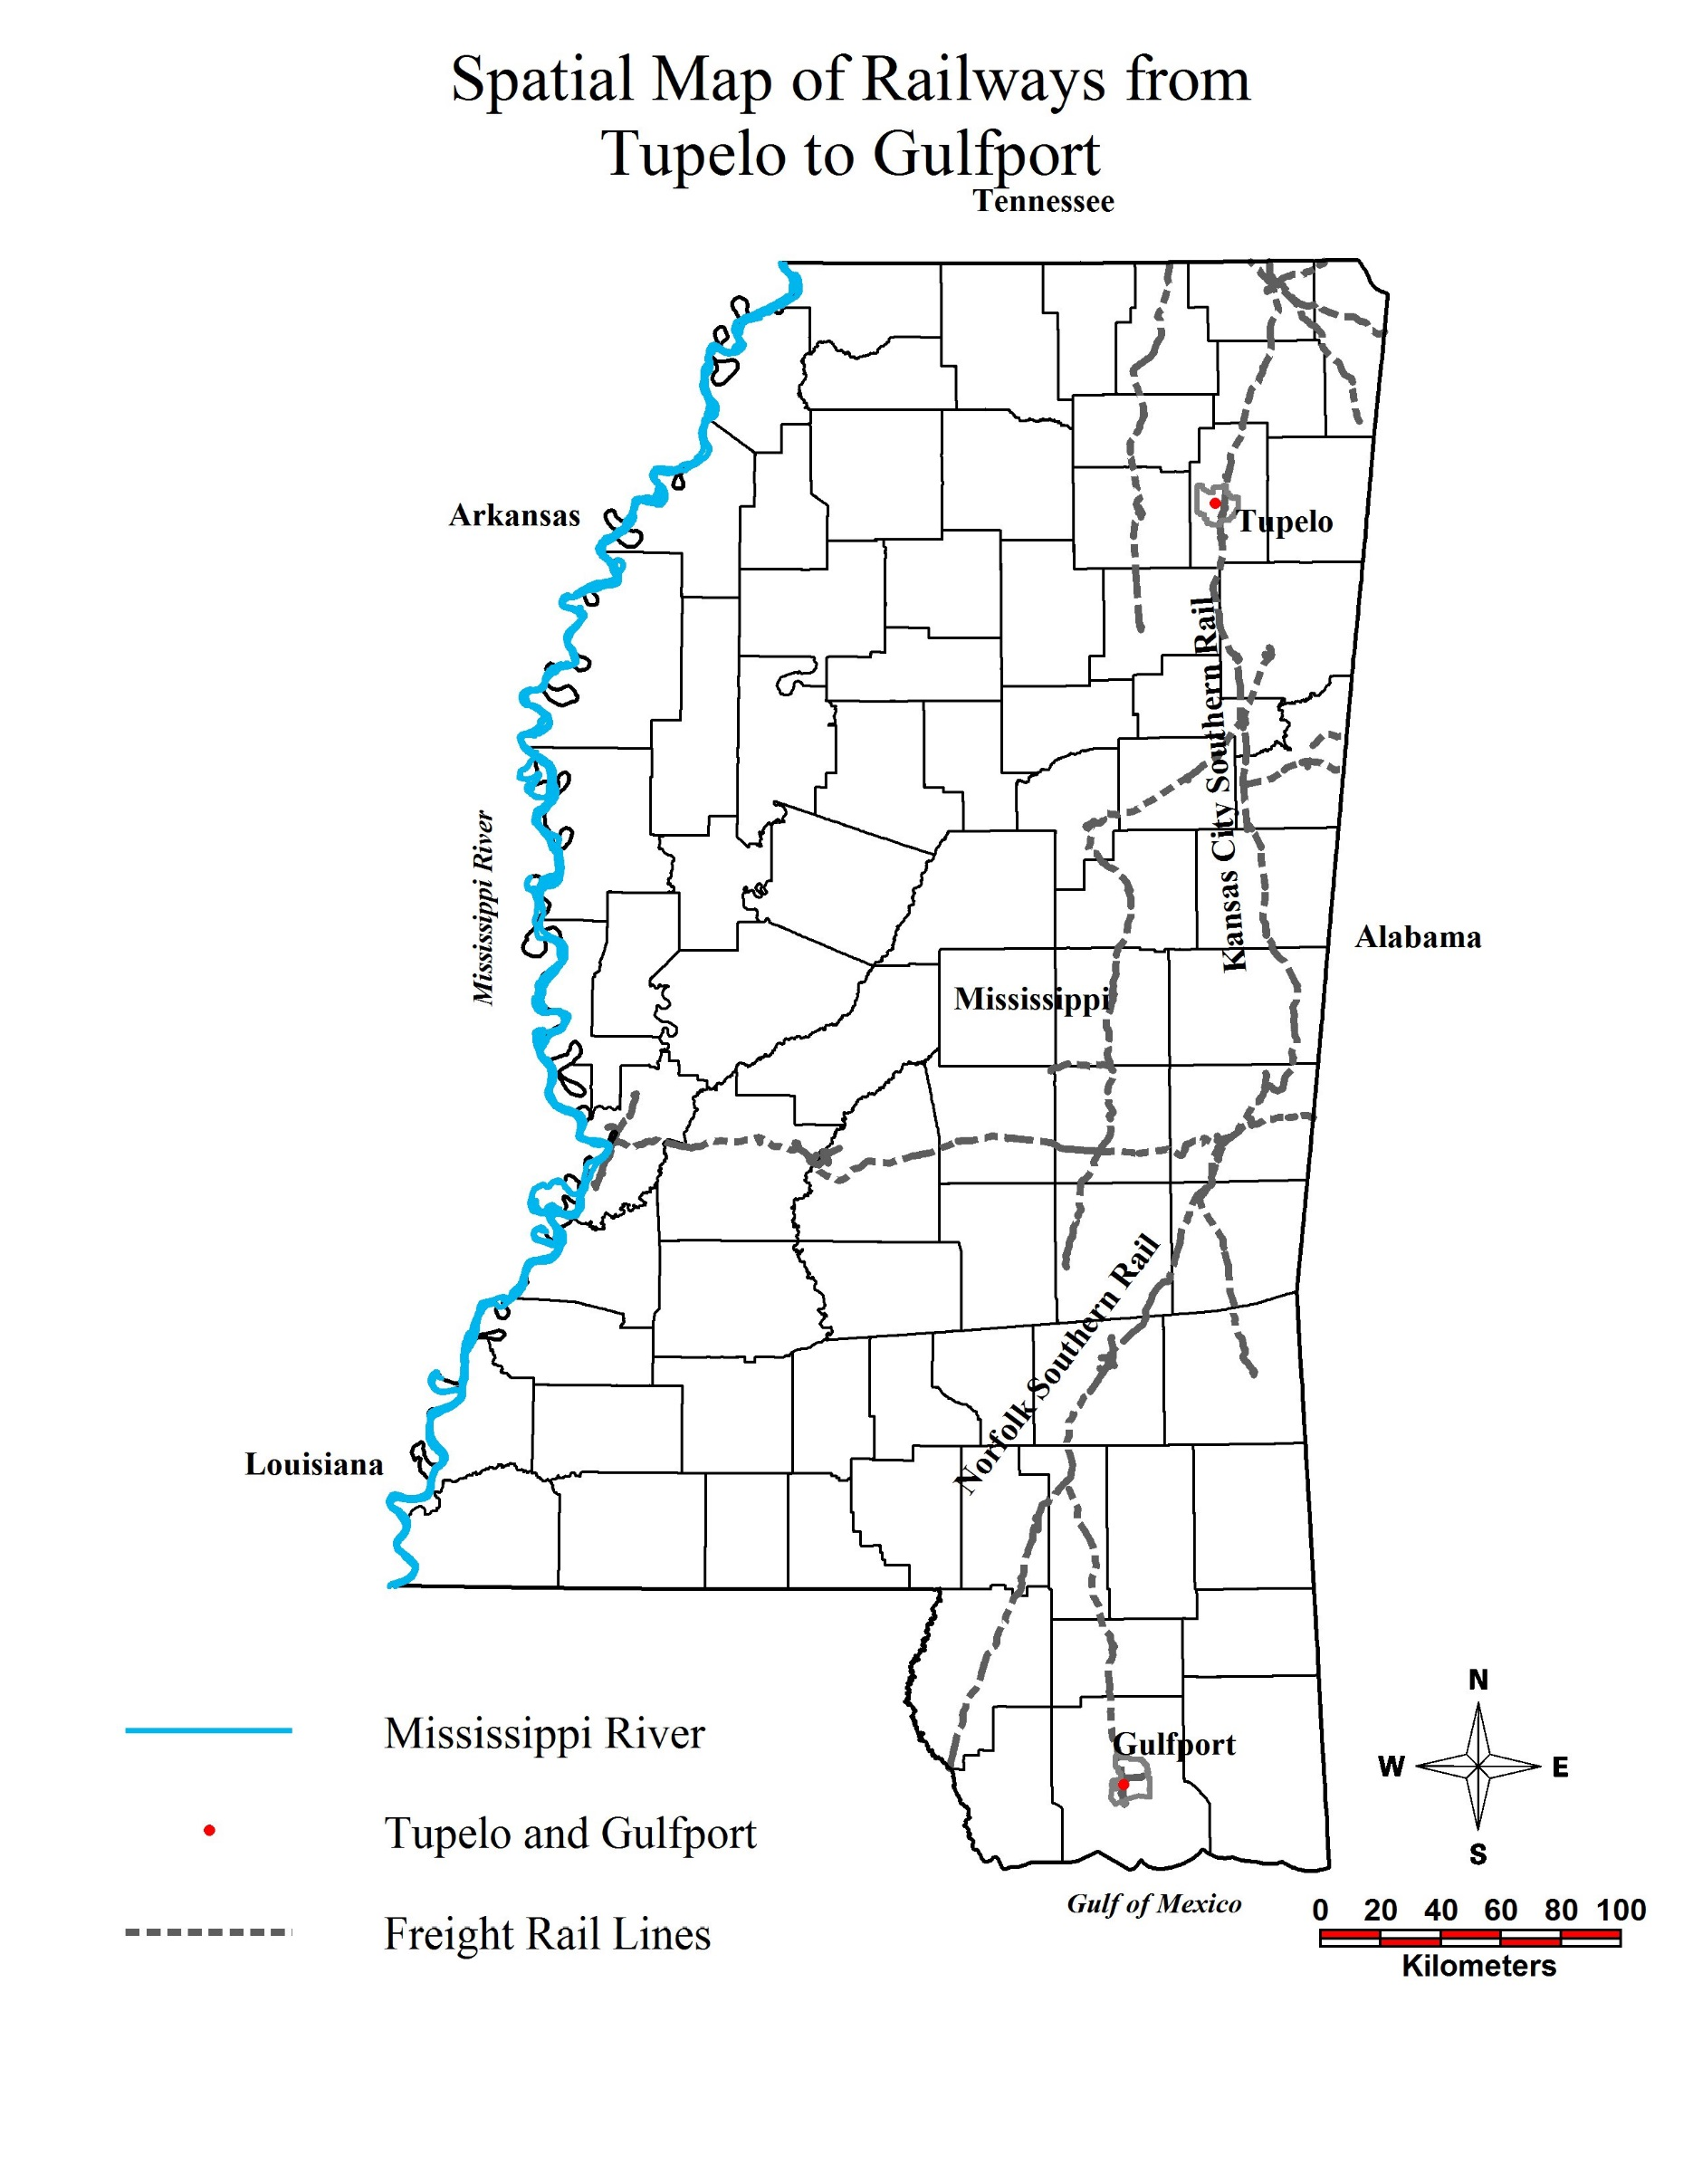

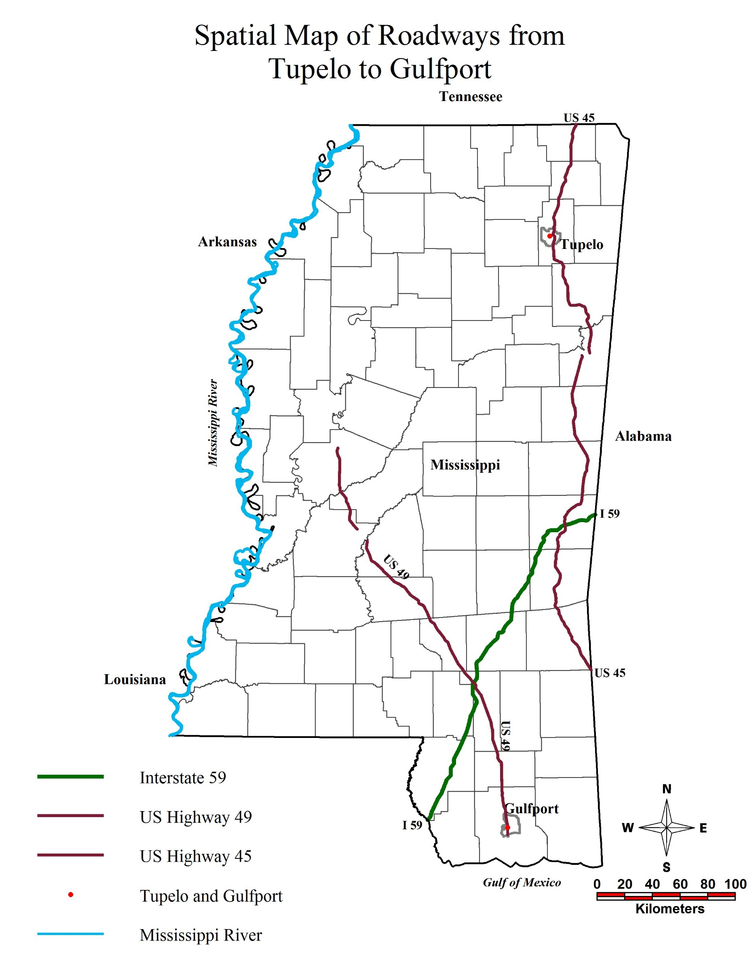

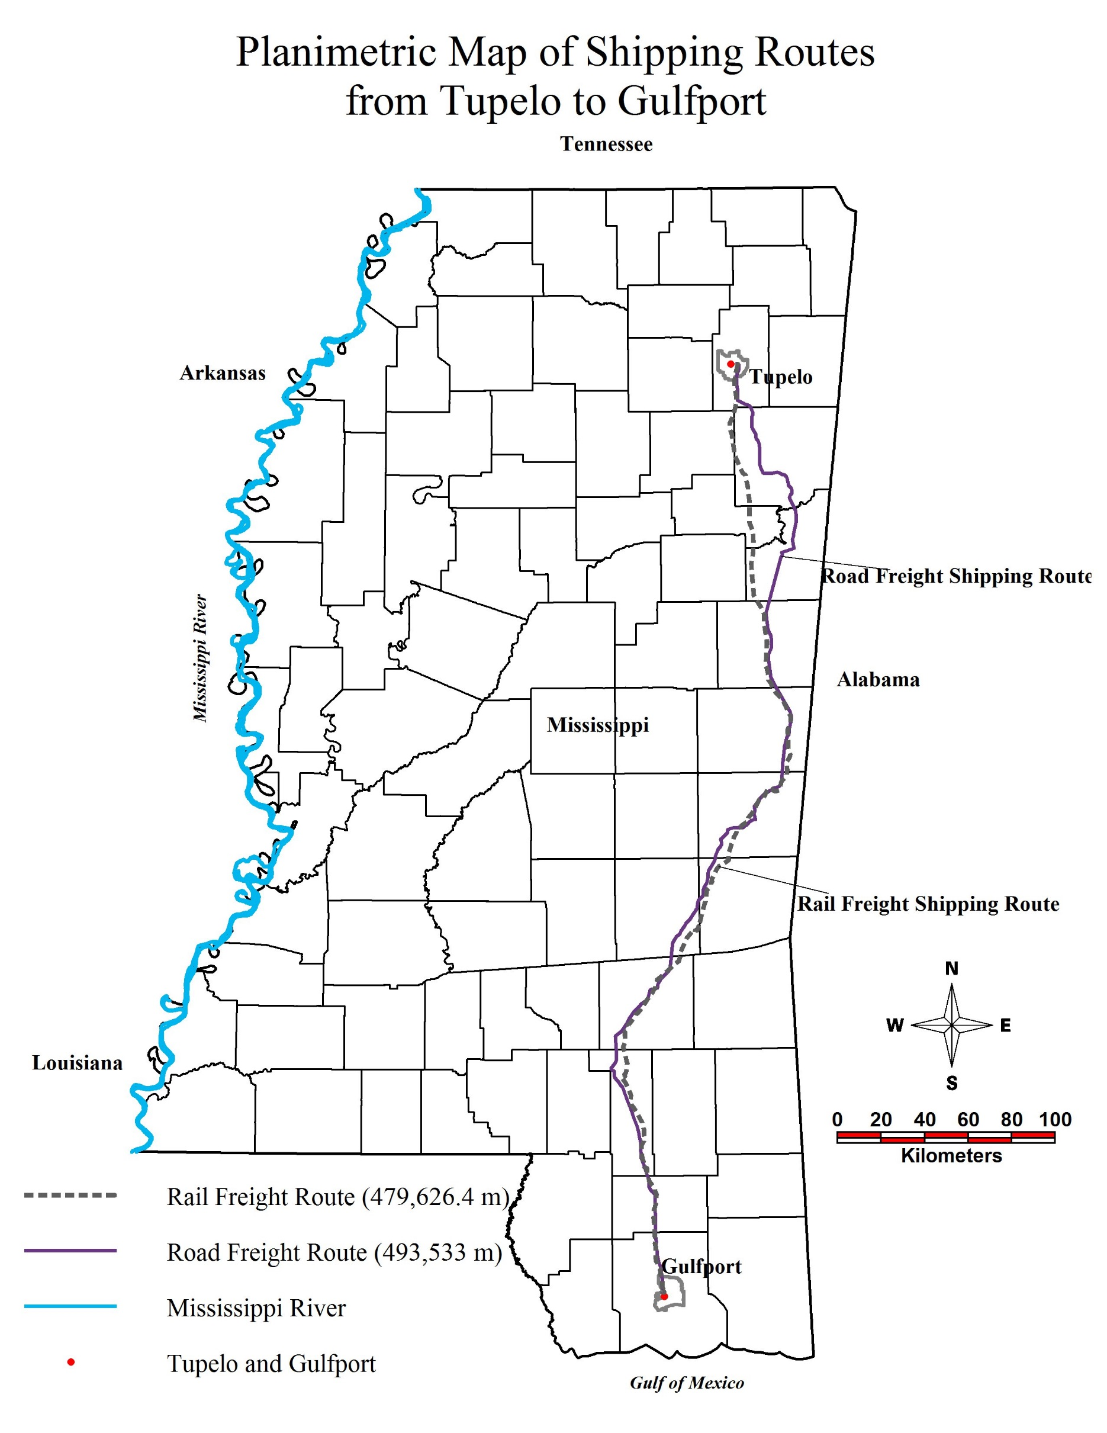

|  |  |  |
| --- | --- | --- |
| Pollutant | Emission Rate-Truck (g/km/veh) | Emission Rate-Rail (g/km*ton/veh) |
|
| CO2 | 1,059.883 | 16.146 |
| NOx | 1.738 | 0.136 |
| PM10 | 0.129 | 0.00282 |
| PM2.5 | 0.165 | 0.00424 |

Emission Rate per vehicle as calculated using data acquired from Dr. Waheed and the EPA

|  |  |  |
| --- | --- | --- |
| Present (2017) | | |
| Pollutant | Emissions-Truck (kg/veh) | Emissions-Rail (kg/veh) |
|
| CO2 | 523.09 | 859,571.66 |
| NOx | 0.86 | 7,240.29 |
| PM10 | 0.06 | 150.13 |
| PM2.5 | 0.08 | 225.73 |

Emission Produced by Cotton Shipping without diversion 2017

|  |  |  |
| --- | --- | --- |
| Present (2017) Diverting 90% Truck Freight to Rail | | |
| Pollutant | Emissions-Truck (kg/veh) | Emissions-Rail (kg/veh) |
|
| CO2 | 523.09 | 7,979,982.65 |
| NOx | 0.86 | 67,216.5 |
| PM10 | 0.06 | 1,393.75 |
| PM2.5 | 0.08 | 2,095.57 |

Emission Produce by Cotton Shipping Diverting 90% Truck Freight to Rail

|  |  |  |
| --- | --- | --- |
| Present (2017) Diverting 50% Rail Freight to Truck | | |
| Pollutant | Emissions-Truck (kg/veh) | Emissions-Rail (kg/veh) |
|
| CO2 | 523.09 | 429,785.83 |
| NOx | 0.86 | 3,620.15 |
| PM10 | 0.06 | 75.06 |
| PM2.5 | 0.08 | 112.86 |

Emission Produced by Cotton Shipping Diverting 50% Rail Freight to Truck

|  |  |  |
| --- | --- | --- |
| Classification | Shipment by Road (ton*mile) | Shipment by Rail (ton*mile) |
| Undiverted Shipping (2027) | 853,639,638.3 | 90,132,337.02 |
| Divert 90% Truck to Rail (2027) | 85,363,963.83 | 836,759,185.9 |
| Divert 50% Rail to Truck (2027) | 900,012,523.3 | 45,066,168.51 |

Shipment Data per Method Using Forecasting into 2027 Assuming a 2% Growth Rate

|  |  |  |
| --- | --- | --- |
|  | |  |
| **Value of Production** | | 5,366,380 acres |
| *Product* | *Worth ($/acre)* | *Worth ($)* |
| Cotton | 703.8 |  |
| Cottonseed | 81 |  |
| Total Product | 784.8 | 4,211,535,024 |
| **Operating Costs** | | 5,366,380 acres |
| *Item* | *Cost ($/acre)* | *Cost ($)* |
| Seed | 100 |  |
| Fertilizer | 98.31 |  |
| Chemicals | 113.21 |  |
| Operations | 37.47 |  |
| Machinery | 32.45 |  |
| Machine Repair | 53.31 |  |
| Ginning | 196.23 |  |
| Irrigation | 0.52 |  |
| Interest inputs | 1.45 |  |
| Total Operating Costs | 632.95 | 3,396,650,221 |
| **Allocated Overhead Costs** | | 5,366,380 acres |
| *Item* | *Cost ($/acre)* | *Cost ($)* |
| Hired Labor | 18.22 |  |
| Opportunity Cost of Unpaid Labor | 22.25 |  |
| Capital Recovery of Equipment | 171.73 |  |
| Opportunity Cost of Land | 118.99 |  |
| Taxes/Insurance | 11.85 |  |
| General Farm | 16.65 |  |
| Total Overhead Costs | 359.69 | 1,930,233,222 |
| **Added Value Inputs** | | 5,366,380 acres |
| *Item* | *Worth ($/acre)* | *Worth ($)* |
| Government Subsidies | 499.8 | 2,682,116,724 |
| **Added Cost Inputs** | |  |
| *Item* | *Worth ($/t*mi)* | *Worth ($)* |
| Shipping by Truck | 0.0037 | 3,158,466.66 |
| Shipping by Rail | 0.0003 | 27,039.70 |
| Total Shipping Costs | -- | 3,185,506.36 |
| Total Product Value | | 1,563,582,798 |
|

Cost Analysis in 2027 Without Diverting Shipping Methods

|  |  |  |
| --- | --- | --- |
|  | | |
| **Value of Production** | | 5,366,380 acres |
| *Product* | *Worth ($/acre)* | *Worth ($)* |
| Cotton | 703.8 |  |
| Cottonseed | 81 |  |
| Total Product | 784.8 | 4,211,535,024 |
| **Operating Costs** | | 5,366,380 acres |
| *Item* | *Cost ($/acre)* | *Cost ($)* |
| Seed | 100 |  |
| Fertilizer | 98.31 |  |
| Chemicals | 113.21 |  |
| Operations | 37.47 |  |
| Machinary | 32.45 |  |
| Machine Repair | 53.31 |  |
| Ginning | 196.23 |  |
| Irrigation | 0.52 |  |
| Interest inputs | 1.45 |  |
| Total Operating Costs | 632.95 | 3,396,650,221 |
| **Allocated Overhead Costs** | | 5,366,380 acres |
| *Item* | *Cost ($/acre)* | *Cost ($)* |
| Hired Labor | 18.22 |  |
| Opportunity Cost of Unpaid Labor | 22.25 |  |
| Capital Recovery of Equipment | 171.73 |  |
| Opportunity Cost of Land | 118.99 |  |
| Taxes/Insurance | 11.85 |  |
| General Farm | 16.65 |  |
| Total Overhead Costs | 359.69 | 1,930,233,222 |
| **Added Value Inputs** | | 5,366,380 acres |
| *Item* | *Worth ($/acre)* | *Worth ($)* |
| Government Subsidies | 499.8 | 2,682,116,724 |
| **Added Cost Inputs** | |  |
| *Item* | *Worth ($/t*mi)* | *Worth ($)* |
| Shipping by Truck | 0.0037 | 315,846.67 |
| Shipping by Rail | 0.0003 | 251,027.76 |
| Total Shipping Costs | -- | 566,874.43 |
| Total Product Value | | 1,566,201,430 |
|

Cost Analysis in 2027 Diverting 90% Truck Freight to Rail

|  |  |  |
| --- | --- | --- |
| Cost Analysis in 2027 Diverting 50% Rail Freight to Truck | | |
| **Value of Production** | | 5,366,380 acres |
| *Product* | *Worth ($/acre)* | *Worth ($)* |
| Cotton | 703.8 |  |
| Cottonseed | 81 |  |
| Total Product | 784.8 | 4,211,535,024 |
| **Operating Costs** | | 5,366,380 acres |
| *Item* | *Cost ($/acre)* | *Cost ($)* |
| Seed | 100 |  |
| Fertilizer | 98.31 |  |
| Chemicals | 113.21 |  |
| Operations | 37.47 |  |
| Machinary | 32.45 |  |
| Machine Repair | 53.31 |  |
| Ginning | 196.23 |  |
| Irrigation | 0.52 |  |
| Interest inputs | 1.45 |  |
| Total Operating Costs | 632.95 | 3,396,650,221 |
| **Allocated Overhead Costs** | | 5,366,380 acres |
| *Item* | *Cost ($/acre)* | *Cost ($)* |
| Hired Labor | 18.22 |  |
| Opportunity Cost of Unpaid Labor | 22.25 |  |
| Capital Recovery of Equipment | 171.73 |  |
| Opportunity Cost of Land | 118.99 |  |
| Taxes/Insurance | 11.85 |  |
| General Farm | 16.65 |  |
| Total Overhead Costs | 359.69 | 1,930,233,222 |
| **Added Value Inputs** | | 5,366,380 acres |
| *Item* | *Worth ($/acre)* | *Worth ($)* |
| Government Subsidies | 499.8 | 2,682,116,724 |
| **Added Cost Inputs** | |  |
| *Item* | *Worth ($/t*mi)* | *Worth ($)* |
| Shipping by Truck | 0.0037 | 3,330,046.34 |
| Shipping by Rail | 0.0003 | 13,519.85 |
| Total Shipping Costs | -- | 3,343,566.19 |
| Total Product Value | | 1,563,424,739 |
|